# CS 255 System Design Document Template

## UML Diagrams

### UML Use Case Diagram

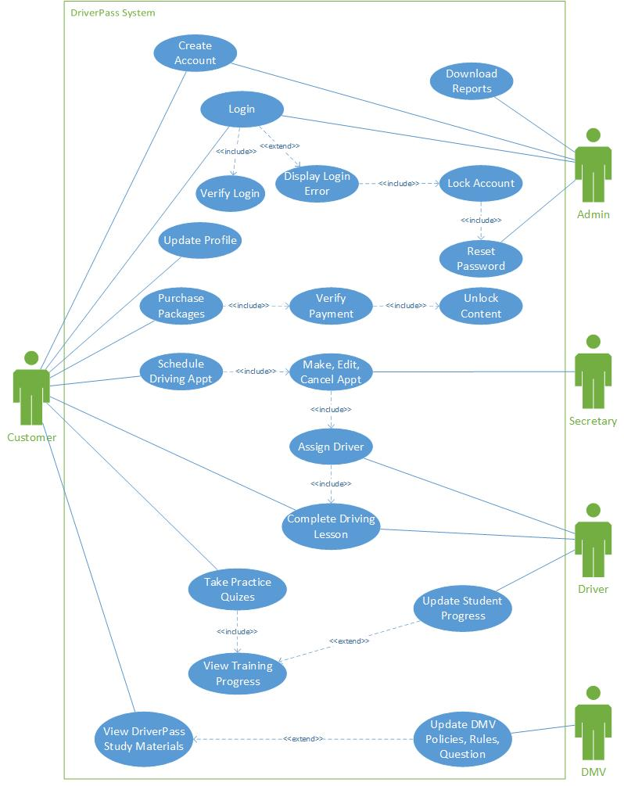

### UML Activity Diagrams

1. **Booking a Driving Lesson**

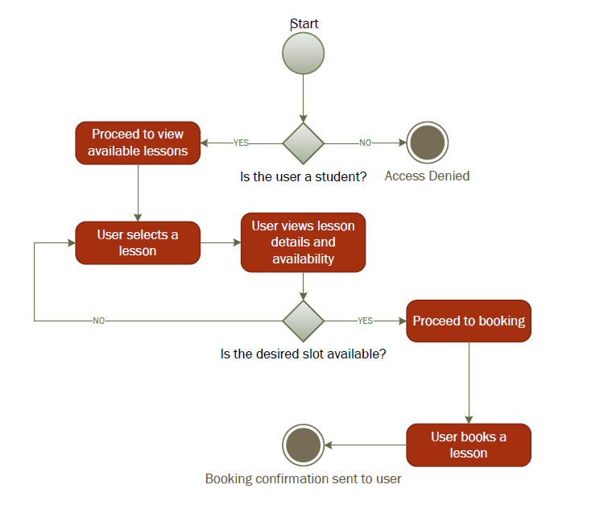

1. **Taking an Online Practice Exam**

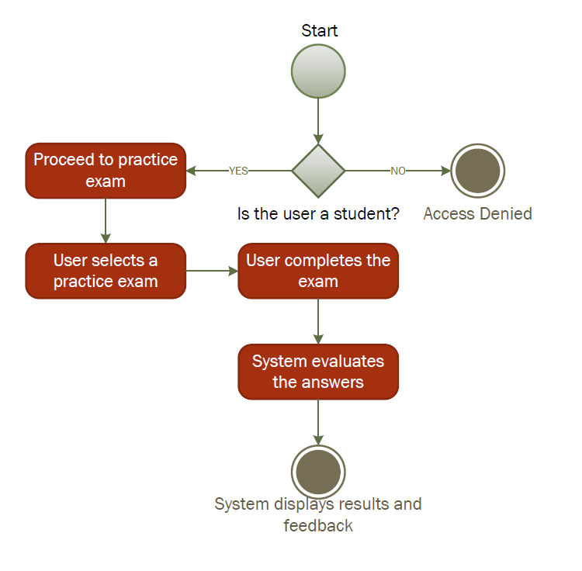

### UML Sequence Diagram

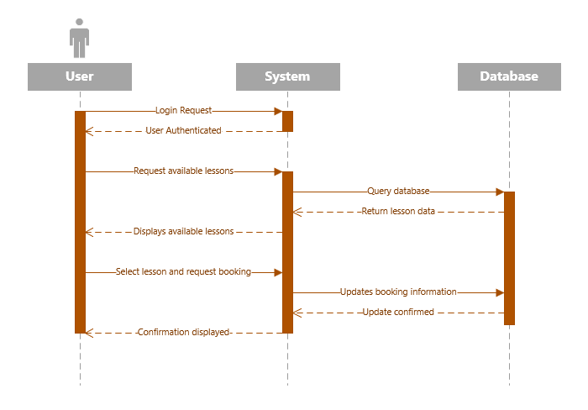

### UML Class Diagram

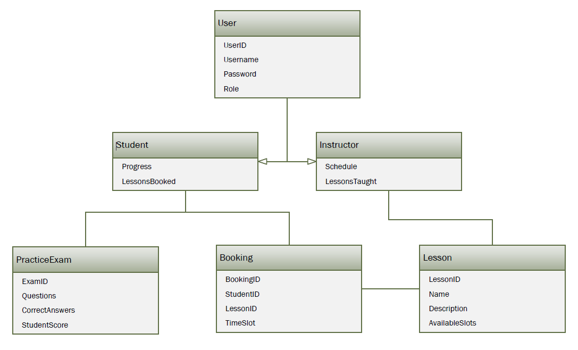

## Technical Requirements

**Hardware Requirements**

* **Servers:** Reliable server infrastructure for hosting the application, database, and backup solutions.
* **User Devices:** Support for a range of devices including smartphones, tablets, and computers for accessing the web and mobile applications.

**Software Requirements**

* **Database Management System (DBMS):** A robust DBMS like MySQL or PostgreSQL for managing user data, lesson bookings, and exam records.
* **Web Server:** Software like Apache or Nginx to serve the web application.
* **Development Frameworks:** Use of frameworks such as React for the frontend and Node.js or .NET for the backend to build a responsive and scalable application.

**Tools**

* **Integrated Development Environment (IDE):** Tools like Visual Studio Code or IntelliJ IDEA for coding and debugging.
* **Version Control System:** Git, along with platforms like GitHub or GitLab, for source code management.
* **Lucid chart:** For creating and maintaining UML diagrams as part of the documentation process.

**Infrastructure**

* **Cloud Services:** Utilization of cloud platforms like AWS or Azure for hosting, scalability, and security services.
* **Content Delivery Network (CDN):** A CDN to ensure fast delivery of content to users worldwide.
* **Security Infrastructure:** Implementation of SSL/TLS for secure communication, firewalls, and regular security audits.

These requirements ensure the system is scalable, secure, and capable of providing a seamless user experience while meeting the business and functional needs outlined in the DriverPass system design.